**.NET Application Programming**

**Project Status and Design Report**

|  |  |  |
| --- | --- | --- |
| **Topic:** | *FR4, FR4.5 Part 2* | |
| **Date:** | *10-17-2020* | |
| **Revision:** | *4.0* | |
| **Team:** | 1. *Matt Sievers* | |
| 1. Crystal Sciarrino | |
|  | |
|  | |
| **Weekly Team Status Summary:** | |  |  |  |  | | --- | --- | --- | --- | | **User Story** | **Team**  **Member** | **Hours**  **Worked** | **Hours Remaining** | | As a developer, I need to update the board model with a new static gameover variable | *Matt Sievers* | *1* | *0* | | As a developer, I need to update the cell model to have a new flag variable to be used for right clicks | *Matt Sievers* | *1* | *0* | | As a team, we need to develop a new partial view for win / loss conditions | *Matt Sievers / Crystal Sciarrino* | *2* | *0* | | As a developer, reuse logic from CST 227 win / loss to set GameOver flag once met | *Matt Sievers* | *2* | *0* | | As a developer, I need to allow users to right click on the game board and add a flag for possible bombs | *Matt Sievers* | *8* | *0* | | As a developer, I need to add hashing logic to the password input into create user so we're not storing readable passwords | *Crystal Sciarrino* | *6* | *0* | | As a team, we need to do weekly scrum paperwork | *Matt Sievers / Crystal Sciarrino* | *2* | *0* | |  |  |  |  | |  |  |  |  | |  |  |  |  | |  |  |  |  | |  |  |  |  | |  |  |  |  | |  |  |  |  | |  |  |  |  | |  |  |  |  | | |
| **GIT URL:** | https://github.com/Malleas/CLCMinesweeperApp | |
| **Peer Review:** | *Y* | We acknowledge that our team has reviewed this Report and we agree to the approach we are all taking. |

**Planning Documentation**

**Agile Scrum Board:**

[**https://www.meistertask.com/app/project/sSO4jU4u/cst-247**](https://www.meistertask.com/app/project/sSO4jU4u/cst-247)

**Agile Scrum Product Backlog:**

https://github.com/Malleas/CLCMinesweeperApp/tree/master/CLCMinesweeperApp/Planning%20and%20Design/Week%205

**Agile Scrum Sprint Backlog:**

*https://github.com/Malleas/CLCMinesweeperApp/tree/master/CLCMinesweeperApp/Planning%20and%20Design/Week%205*

**Agile Scrum Burn Down Chart:**

*https://github.com/Malleas/CLCMinesweeperApp/tree/master/CLCMinesweeperApp/Planning%20and%20Design/Week%205*

**Agile Retrospective Results:**

*The following table should be completed after each Retrospective on Things That Went Well (Keep Doing). An alternative to the following table is to use a Mind Mapping tool such as Coggle. If you use a Mind Mapping tool you must include a URL or Image File.*

|  |
| --- |
| **What Went Well** |
| **Able to get the remaining gameboard logic implemented.** |
| **Great working sessions as we did peer coding this week as well. Working on the partial view as a team sharing code and screens.** |
|  |

*The following table should be completed after each Retrospective on Things That Didn’t Go Well (Stop Doing) and What Would Be Done Differently Next Time with an Action Plan to Improve (Try Doing and Continuous Improvement). An alternative to the following table is to use a Mind Mapping tool such as Coggle. If you use a Mind Mapping tool you must include a URL or Image File.*

|  |  |  |
| --- | --- | --- |
| **What Did Not Go Well** | **Action Plan** | **Due Date** |
| Incomplete requirements. Functional Gameboard, Login and Registration page is not clear direction of the want/need. | None. Clarification was asked for in week 3 because the same requirement was asked of. Implemented what we could to make the board work as it did in CST227. Still missing a timer, turn counter and score. |  |
| **Assignment and CLC did not match up. There was little to no direction on how to do any of this weeks work.** | **Thankfully we found Prof. Sluiter’s videos on youtube that helped set up the right click as well as the assignments. These need to be shared with online students.** |  |
|  |  |  |

**Design Documentation**

**Install Instructions:**

*Connect and pull from master from repo. Refer to DDL scripts before running as a local DB will need to be created and table added. Click debug menu option and select Run without debug. Backup provided of DB for full install as needed.*

*DB Has not changed for this version, please use DB.bak sent in separate email as we cannot submit via loudcloud system*

**General Technical Approach:**

*Needed a second click listener for the right click button. Needed to ensure no game logic was fired based on a right click. Also wanted a partial view that was not visible till a flag was set based on win / loss condition. The win / loss logic could be recycled from CST227 project.*

**Key Technical Design Decisions:**

*Reusing CST227 code for win / loss logic saved a ton of time. We also found in a peer coding meeting that you can use a model location as an argument to an if statement using a static variable to check. IE if(project.model.Board.GameOver){…}. We were both amazed that worked and allowed for the partial view to be hidden.*

**ER Diagram:**

*n/a for this requirement*

**DDL Scripts:**

*CREATE TABLE [dbo].[Player]*

*(*

*[USERID] INT NOT NULL PRIMARY KEY IDENTITY(1,1),*

*[FIRSTNAME] VARCHAR(50) NOT NULL,*

*[LASTNAME] VARCHAR(50) NOT NULL,*

*[GENDER] VARCHAR(50) NOT NULL,*

*[AGE] INT NOT NULL,*

*[STATE] VARCHAR(2) NOT NULL,*

*[EMAILADDRESS] VARCHAR(100) NOT NULL,*

*[USERNAME] VARCHAR(50) NOT NULL,*

*[PASSWORD] VARCHAR(50) NOT NULL*

*)*

**Sitemap Diagram:**

*N/A not required for this FR*

**Security Design:**

*Added hashing to the password entry at new user creation so we’re not storing actual passwords into the db.*

**Third Part Interface Design:**

*NA*

**Flow Charts:**

*NA*

**User Interface Diagrams:**

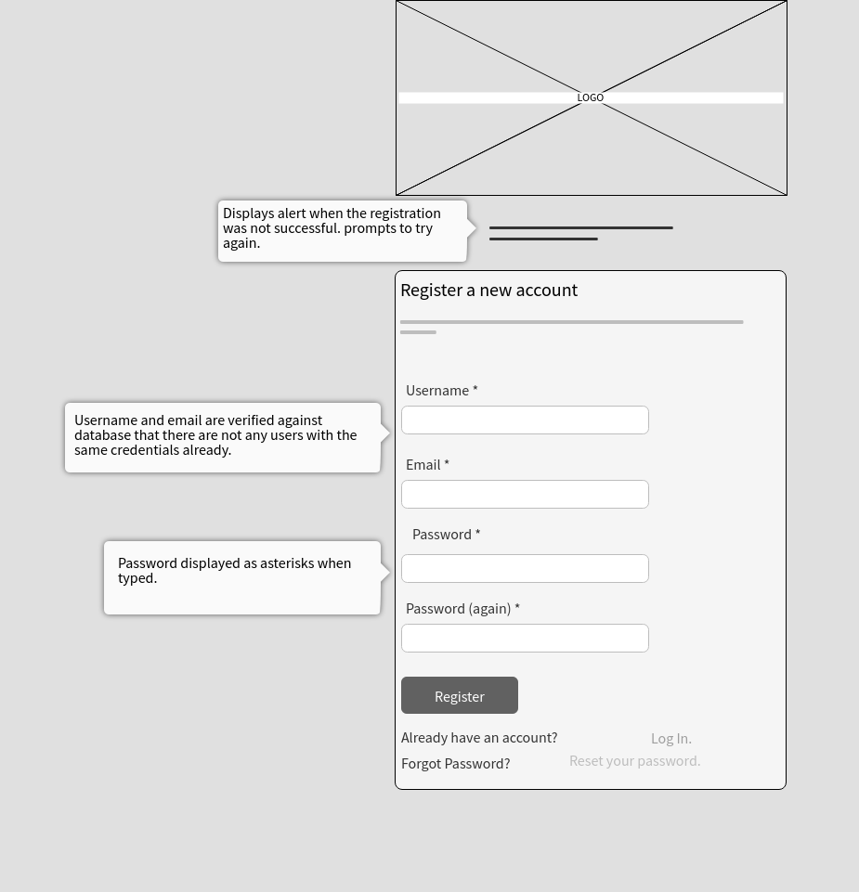

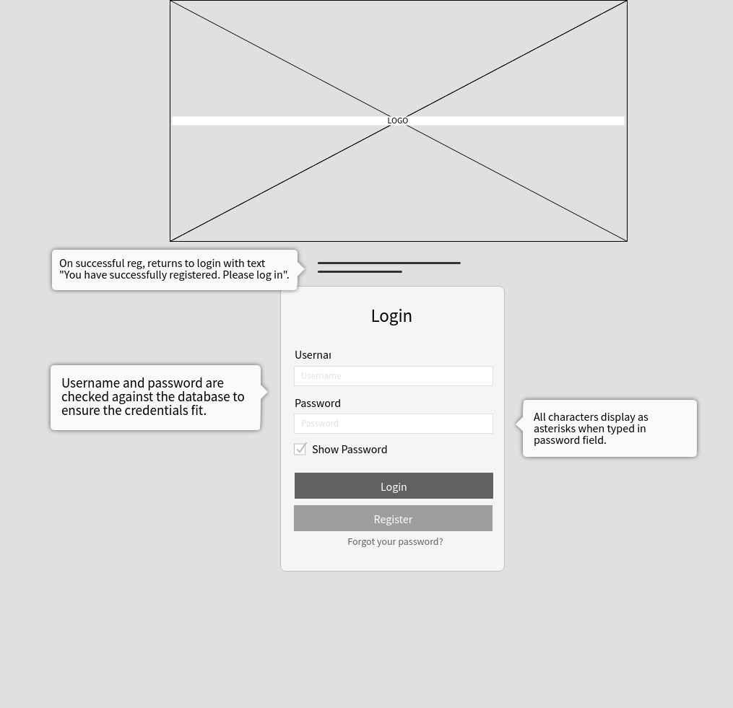

**Class Diagrams:**

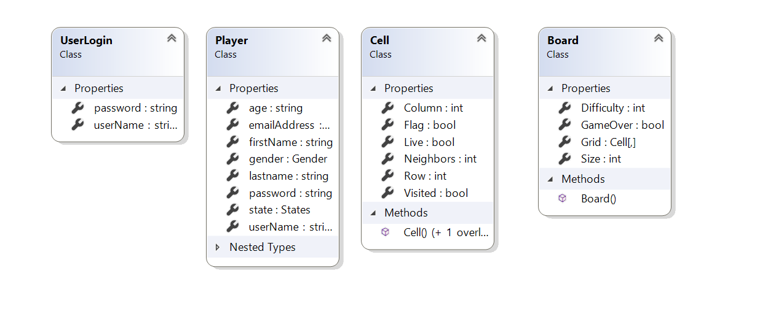

**Pseudo Code:**

*N/A*

**Other Documentation:**

*N/A*